|  |  |  |  |
| --- | --- | --- | --- |
|  | | |  |
| epay  ProjectUser Manual  V1.0 | | | **《基于蓝牙的支付和理财系统》**  **用户操作手册** |
|  |  |

|  |
| --- |
|  |

**目 录**

epay 1

Project User Manual 1

V1.0 1

1 Individual users 4

1.1. System registry 4

1.2. The registered business 4

1.3. Trading business 5

1.3.1 Payment 6

1.3.2collection 7

1.3.3 Cash 7

1.3.4 Transfer 8

1.4 The wealth management business 9

1.4.1 Deposit Money 10

1.4.2 Interest Money 11

1.4.3 Banking Enquiry 11

1.5 Transactions 11

1.5.1 my checks 12

1.5.2 Transaction 13

1.6 set up business 13

1.6.1Change Password 14

1.6.2 Modify gesture password 15

1.6.3 Modify phone numbers 15

1.7 The correlation function 16

1.7.1Contact Customer Service 17

1.7.2 Exit the program 17

II Self-employed users 17

2.1 The system registry 17

2.2 Registered Business 18

2.3 The collection business 19

2.4 Modify the information 20

2.4.1Change Password 21

2.4.2Modify gesture password 22

2.4.3Modify phone numbers 22

2.5 Check-dimensional code 23

2.6 Exit the program 24

III Official Website 24

3.1 The system login 24

3.2 The balance inquiry 25

3.3 report the loss handling 26

3.4 The financial information View 26

3.5 Exit the system 27

IV Supermarket salesperson 28

4.1 The system registry 28

4.2 Upload pictures 28

4.2.1View thumbnails 29

4.2.2Add a picture 30

4.2.3Delete the picture 31

4.2.4complete the upload 33

4.3 run the server 33

# Individual users

## System registry

Open epay individual client，enter the login screen first.

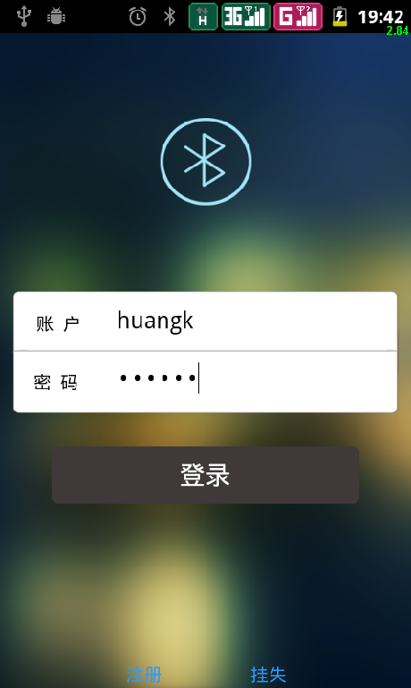

Enter the account number, password，Click the [Login] button to log on.

Click [Register] then jump to the registration page.

Click to [report the loss] Jump to the official website to report the loss.

## 1.2.The registered business

In the login screen, click [Register] button to go to the registration page.

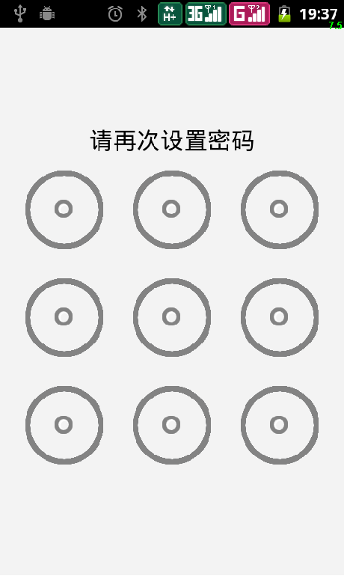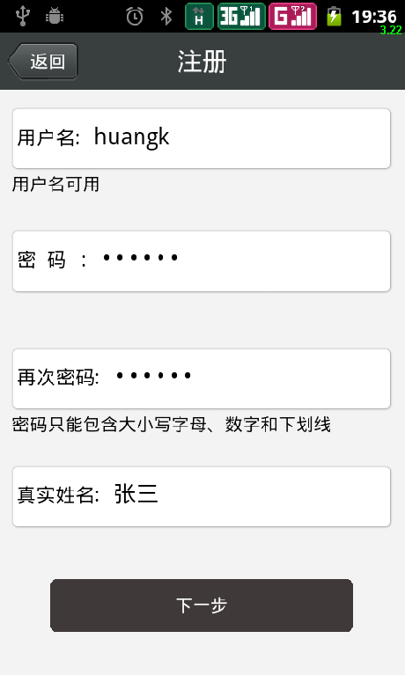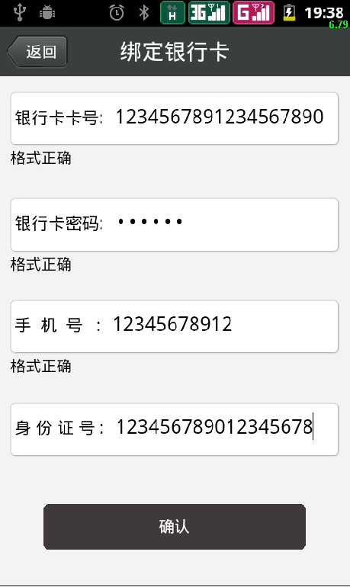

Enter the user name, password, confirm the password, and real name, After entering the user name will then automatically detect whether the user name is available, If not available you will need to re-enter your user name to register. After successful registration,，entering gesture Settings page to enter the password, Gestures need to enter the password twice，If the two doesn’t match, Then back to the first set gesture password interface, Until the same password twice the input gesture, gestures password has been set so far. After the success of gesture password settings will jump to bind bank card interface.

In the Bank card binding interface, input bank card, bank card password, phone number and ID number, the confirmation message, click [OK] button to submit information. If the information on the server-side is verified, then jump to the login page. Otherwise, the display bound to fail.

## 1.3.Trading business

After successful login into the home page, the first page displayed is the transaction (Home), Here you can select the payment, receivables, cash and transfers four different business.

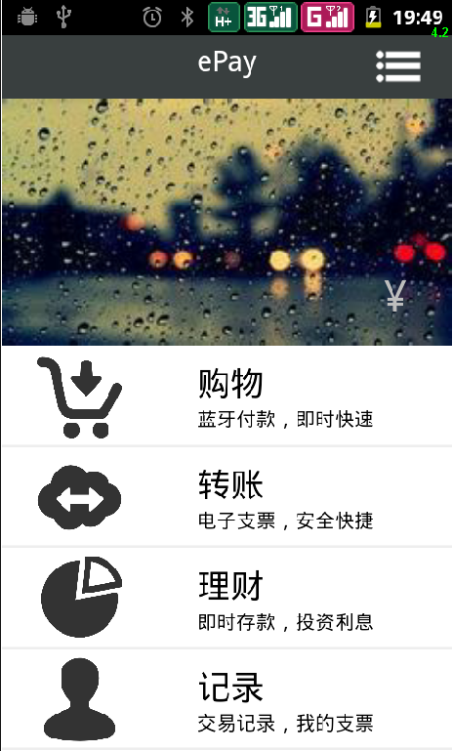

### 1.3.1 Payment

On the home page click on [Payment] button to jump to the page scan two-dimensional code, here, if the self-employed merchants dimensional code scanning, the scan will show the self-employed user's information after the success of the scan, and the phone via Bluetooth with a computer connected to the self-employed; If the two-dimensional code scanning supermarket, then let the user to select the information is displayed Shopping guide or direct shopping, supermarket cashier while completing phones and computer connections. After reading the information in the former can enter the shopping guide shopping.

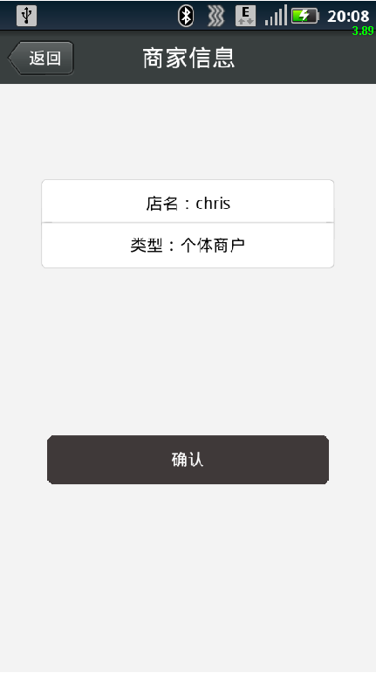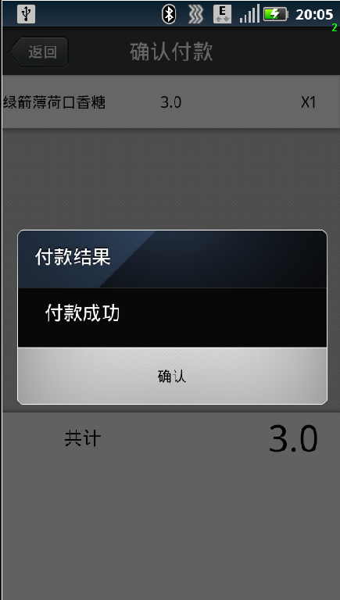

Into the shopping later, in choosing the items to be purchased, as long as the bar code with the camera scanning items, then the software will add to purchase the item list, click on the shopping finished [Payment] button again to complete the payment.

### 1.3.2collection

Receipts and transfers is used together with the others to their transfer, only to connect Bluetooth , which would go to the electronic check their phones up.

### 1.3.3 Cash

Click the [Home] button to go to [fulfill] cashed page. Cashing in on the page shows the current all electronic checkthey own.

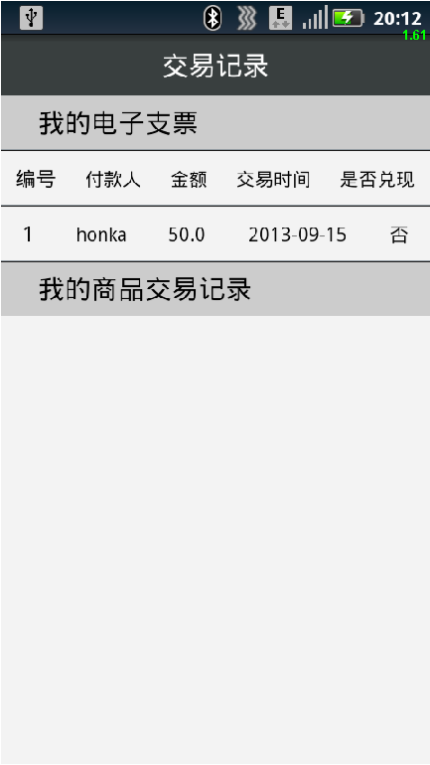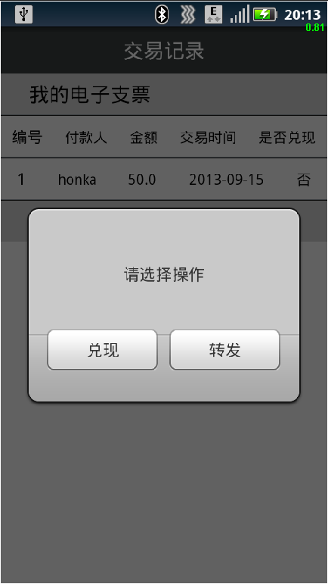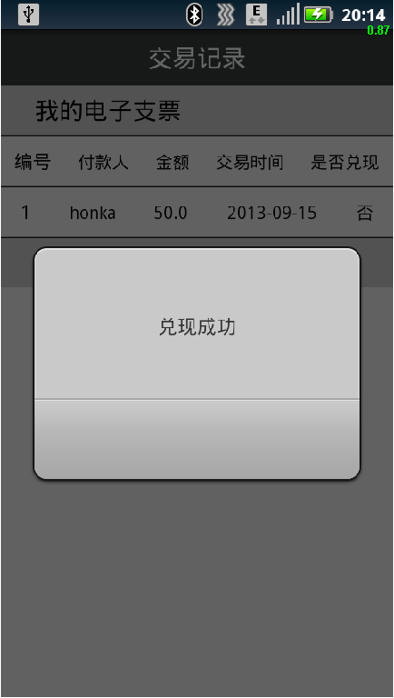

Connect to the network, click [honor] button to complete the cash in the bank side. Cashing function can be used when you need networking, is to fulfill the functions of the party received a bank-side electronic check processing, which truly put the money from the original account to their account up.

### 1.3.4 Transfer

First, the transfer function is declared here and different from the general when we handled the bank transfer, the software which does not require networking reasons, where the transfer is somewhat similar to an electronic checks out.

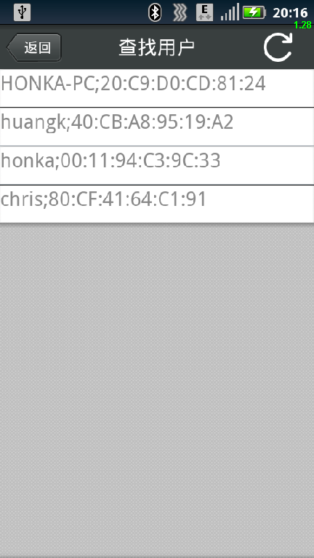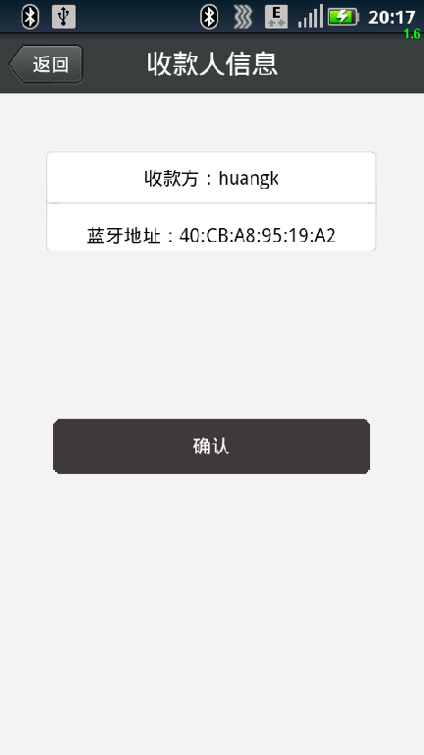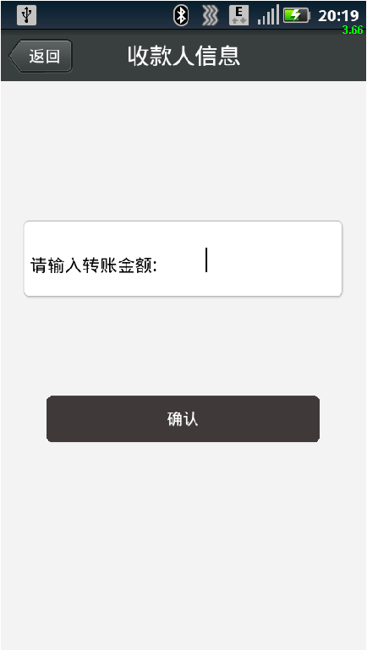

On the home page click [Transfer] button to enter the Transfers page. Transfer screen, click the [Search] icon will search the current user exists around. Select the desired transfer target, click on transfers, fill in the relevant information and the transfer amount, and click [Transfer] button when the user while being transferred receivables is opened, it can be transferred to the recipient of the e-check

## 1.4The wealth management business

After the success recorded into the home page, you can click the button to enter the [financial] Money page. In fiscal interface has three buttons, which are deposits of financial management，Banking deposits were【Deposit Money】,【Interest Money】and【Financial Information】.

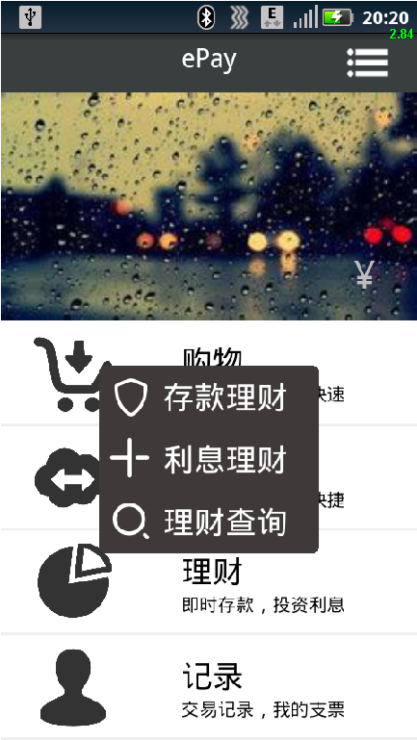

### 1.4.1 Deposit Money

Click [Depoist Money] to enter the deposit financial interface,it is divided into three columns,respectively, show deposit method, interest calculation methods and deposit amount.

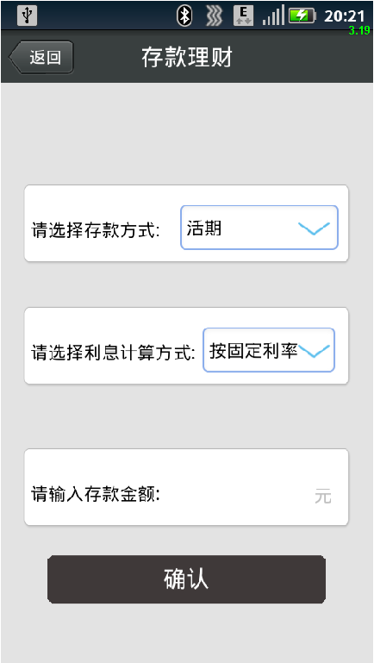

Select the deposit method and interest settlement here, enter the deposit amount，click【Confirm】 button，Money to complete the deposit.

### 1.4.2 Interest Money

Click [Interest Money] to enter the interest Interest Money Money interface, where you can select the interest of investment, in the second column displays all currently owned by the total amount of interest. After choosing investmentinterest, you can click [OK] button to complete the financial interest.

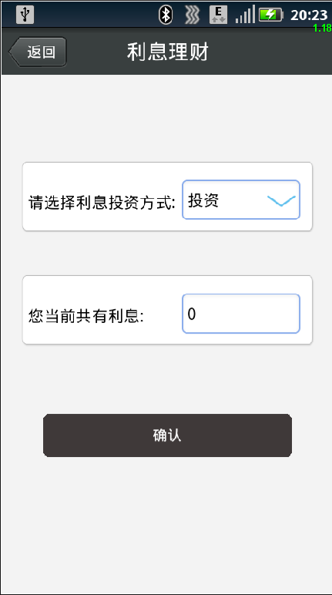

### 1.4.3 Banking Enquiry

Click [financial information] to enter financial information interface, shown here is that all financial products already purchased the relevant information.

## 1.5Transactions

Click [transaction] to enter transaction interface, is shown here [My check] and [check transaction records] two buttons.

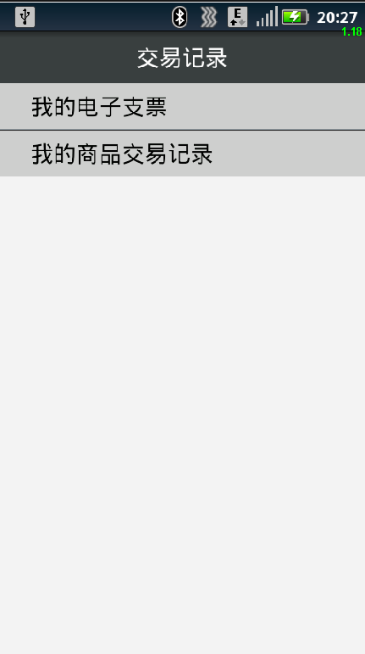

### 1.5.1 my checks

Click [my checks] to enter my check check information query interface, where the show is not yet cashed all current information. Information includes the transfer of people, transfer time, transfer amount.

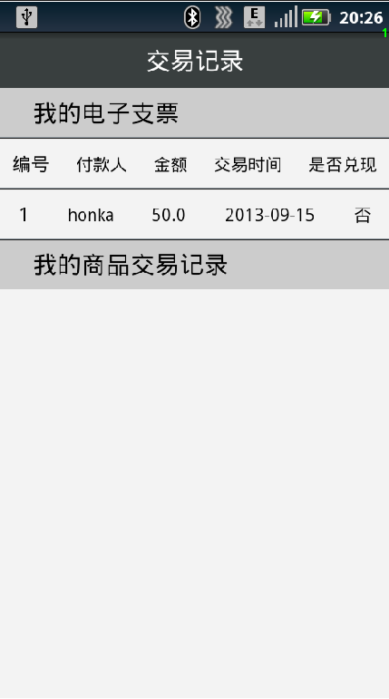

### 1.5.2 Transaction

Click [transaction] to enter the transaction log query interface shown here are all the previous transactions.

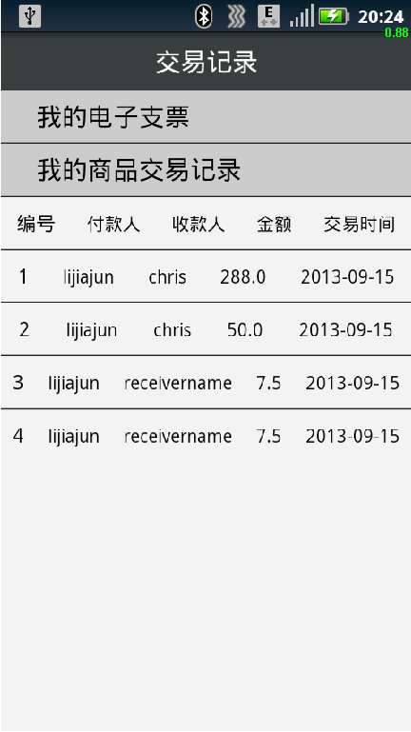

## 1.6 set up business

Click [Setup] to enter the setting interface, shown here with three buttons, which are [Change Password], [Password] and [gestures to modify modify phone number].

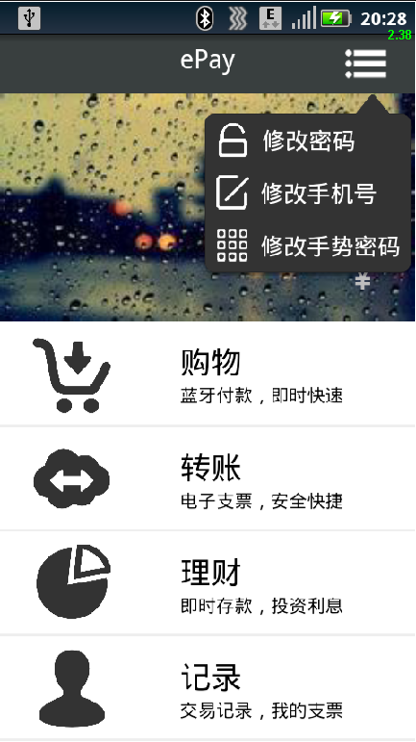

### 1.6.1Change Password

Click [Change Password] to enter the Change Password screen, where you can modify your epay account password information.

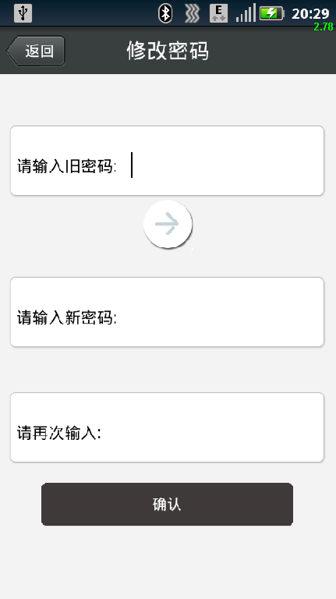

Enter the old password, then click [Verify] button, if the validation fails, you can not type a new password. If the verification is correct, you can type a new password. Enter the new password twice, click [OK] button to complete the modification account password.

### 1.6.2 Modify gesture password

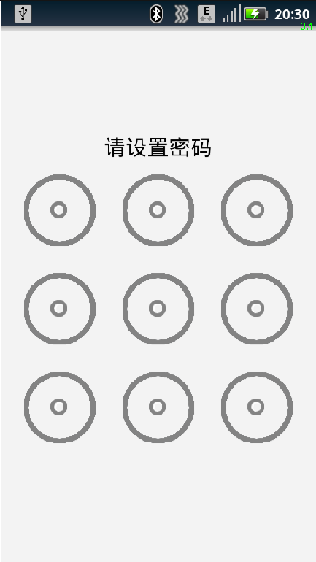

Click [Modify] to enter the password to modify gesture password interface, where you can directly modify the password gestures, gestures need to enter the password twice, if two inconsistent, back to the first set gesture password interface, until input same gesture password, gesture password has been set so far. After the success of gesture password settings will jump to the setting interface.

### 1.6.3 Modify phone numbers

Click [Modify] to enter the mobile phone number mobile phone number to modify the interface. If you want to replace the use of mobile phones, you can access the page.

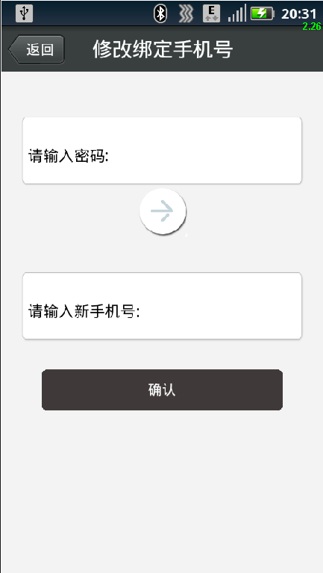

First, enter the password and click [Verify] button, if the validation fails, you can not type a new phone number. If the verification is correct, you can type a new phone number. Enter the new phone number, click on the [OK] button; you can modify the binding to complete phone number.

# IISelf-employed users

## 2.1The system registry

Open epay individual client, first enter the login screen.



Username, password, and click [Login] button to log on.

Click [Register] jump to the registration page.

Click to [report the loss] Jump to the official website, to report the loss on the officialwebsite.

## 2.2 Registered Business

In the login screen, click [Register] button to go to the registration page.

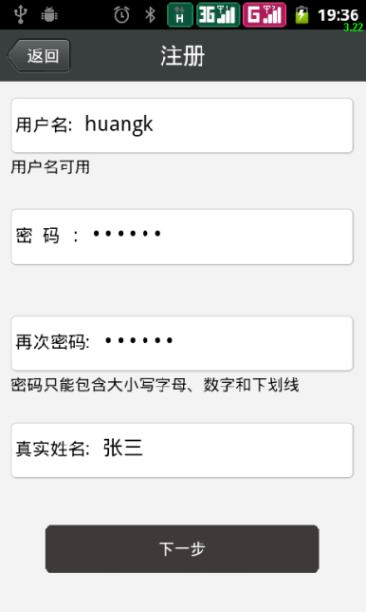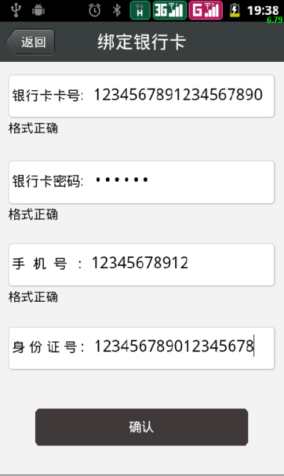

Turn enter the user name, password, confirm the password, and real name, after you finish entering the user name will automatically detect whether the user name is available, if notavailable you will need to re-enter your user name to register.

After successful registration in the account, enter the password settings page gestures, gestures password needs to be entered twice, if the two are inconsistent, then back to the first set gesture password interface until the same password twice the input gesture, gestures password is set successfully so far. After the success of gesture password settings will jump to bind bank card interface.

in the bank card binding interface, input bank card, bank card password, phone number and ID number, the confirmation message, click [OK] button to submit information. If the information on the server-side is verified, then jump to the login page. Otherwise, the display bound to fail.

## 2.3The collection business

After successfully login into the home page, the first page displayed is the transaction (home), where you can collect.



Receipts and transfers is used together with the others to their transfer, click on receivables collection business, to go to the electronic to check their phones up.

## 2.4Modify the information

Click [Setup] to enter the setting interface, shown here with three buttons, which are [Change Password], [Password] and [gestures to modify modify phone number].

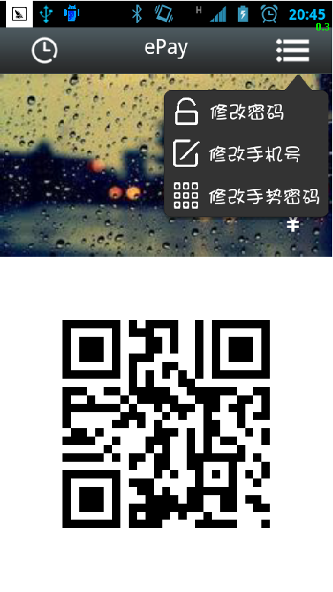

### 2.4.1Change Password

Click [Change Password] to enter the Change Password screen, where you can modify your epay account password information.



Enter the old password, then click [Verify] button, if the validation fails, you can not type a new password. If the verification is correct, you can type a new password. Enter the new password twice, click [OK] button to complete the modification account password.

### 2.4.2Modify gesture password



Click [Modify] to enter the password to modify gesture password interface, where you can directly modify the password gestures, password gestures need to be entered twice, if two inconsistent,go back to the first set gesture password interface, until two input gesture same password, gesture password has been set so far. After the success of gesture password settings will jump to the setting interface.

### 2.4.3Modify phone numbers

Click [Modify] to enter the mobile phone number modifying interface. If you want to replace the use of mobile phones you can access the page

. 

First, enter the password and click [Verify] button, if the validation fails, you can not type a new phone number. If the verification is correct, you can type a new phone number. Enter the new phone number, click on the [OK] button; you can modify the binding to complete phone number.

## 2.5Check-dimensional code

Click [View] into view two-dimensional two-dimensional code code interface. If you want toview the two-dimensional code you canaccess the page.



Click the QRcode, two-dimensional code can be downloaded to the local.

## 2.6Exit the program

Click [Exit] to immediately withdraw from the program software.

# IIIOfficial Website

## 3.1The system login

In the browser, enter the address of the system, such as http://honka.xicp.net, to enter the system login page

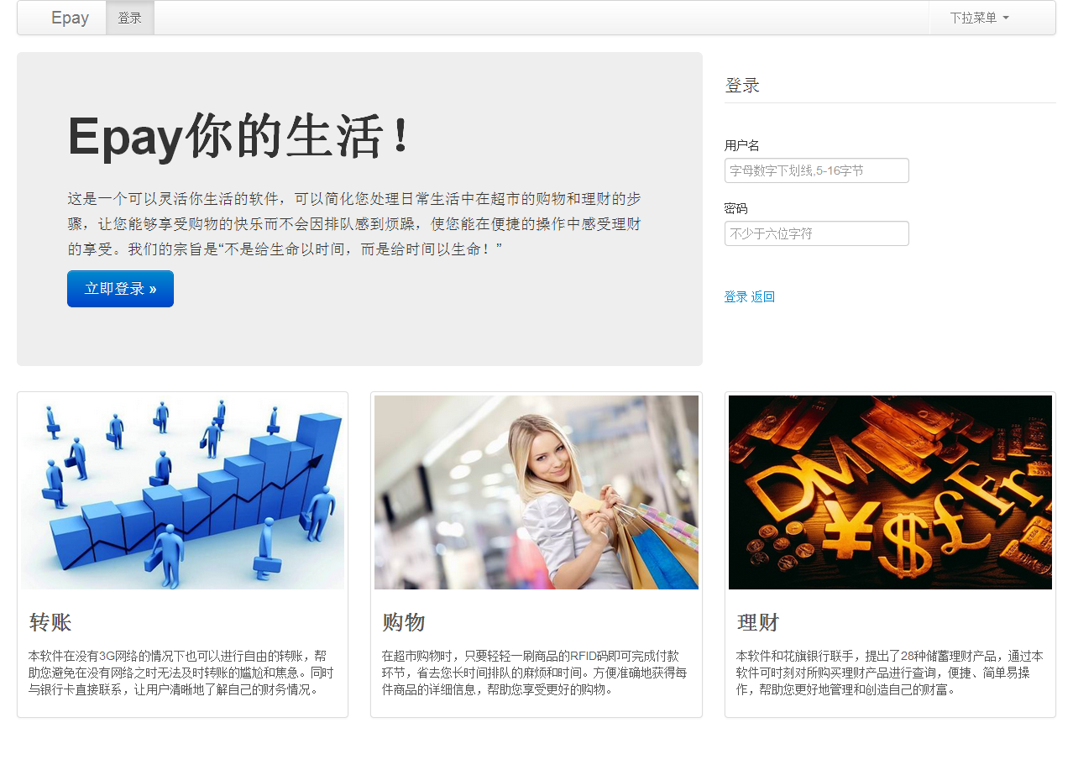

图例：登录页面

Enter your login user name and password, and click [OK] button to log on.

Click the [Cancel] button so that the input data can be emptied.

## 3.2The balance inquiry

If user name and password are correct, then will enter the system, the first page automatically jump to the balance of payments in the expenditure part of the top of the page, and in the bottom of the page is the revenue part.The expenditure distribution is divided into two, the upper part shows the numberof current month until now and a detailed list of expenses, and the following counties are part of a recent five-month total monthly expenditure.

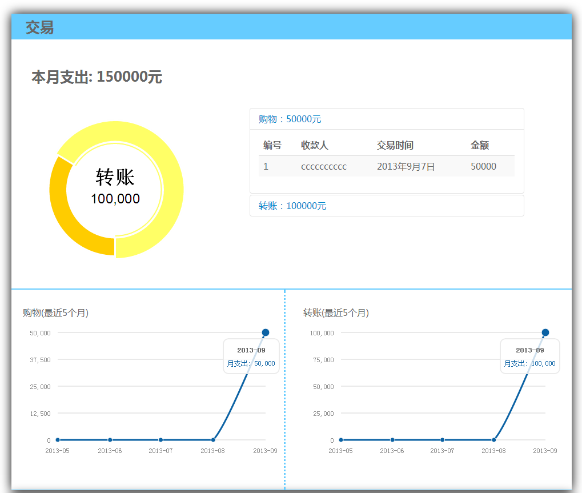

图例：收支查看之支出查看页面

Revenue part is relatively simple, only the most recent five-month transfer income line charts and details of income this month is shown here.

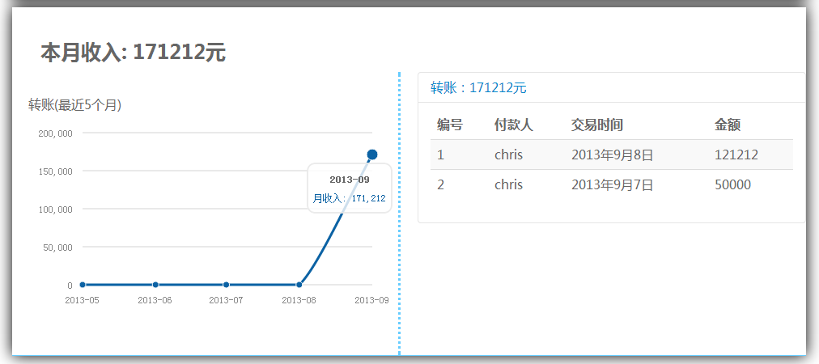

图例：收支查看之收入查看页面

## 3.3 report the loss handling

Click to report the loss of the navigation bar above [Report the loss] to enter the loss reporting interface. If the phone is lost, report the loss in business here. Report the loss can temporarily freeze the account, close the associated shopping business.

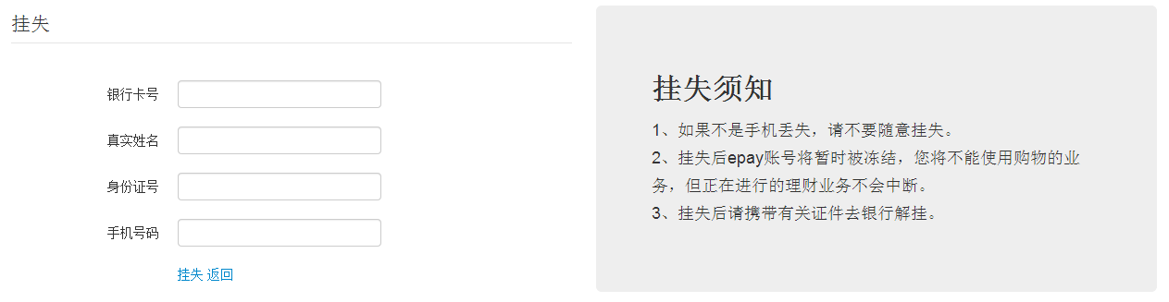图例：挂失办理页面

Fill in the corresponding bank account number, real name, ID number and phone number, You can confirm the correct information click 【Report the loss】 button to report the loss report the loss.

Click the [Back] button to view the balance of payments will be returned to the interface.

## 3.4The financial information View

Click on the navigation bar at the [financial] to enter financial information View interface. Here you can view your principal and interest on the sum of financial products being processed details.

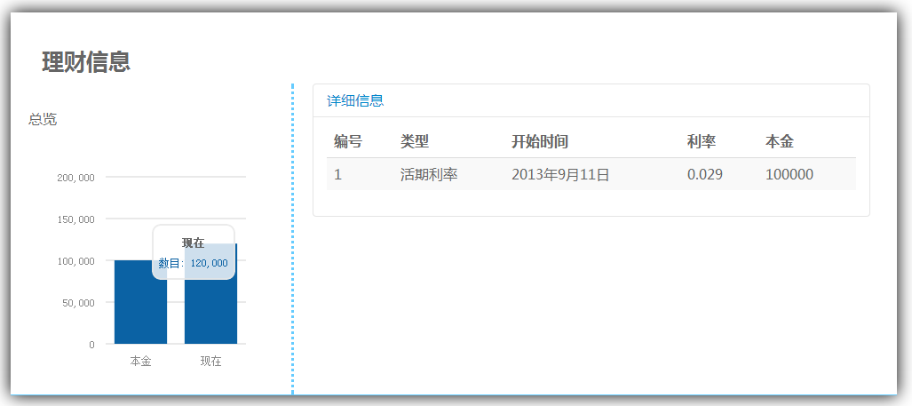图例：理财信息查看页面

As shown, the left side shows the purchase of financial products as well as the principal and all income arising now and. Right is displayed for each one purchased financial products details.

## 3.5Exit the system

Exit the system can click on the top right corner [Exit] button to exit the top right corner of the page can also be found in the drop-down menu click on [Exit] button to exit.

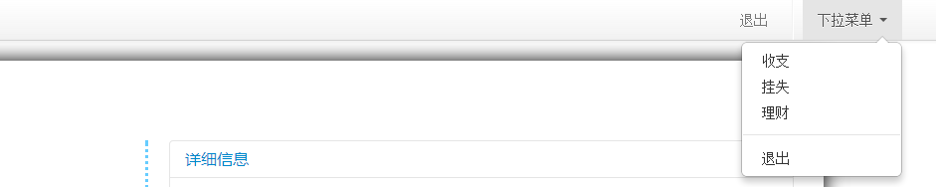

图例：退出按钮显示页面

# IVSupermarket salesperson

## 4.1The system registry

Open the software for system login.

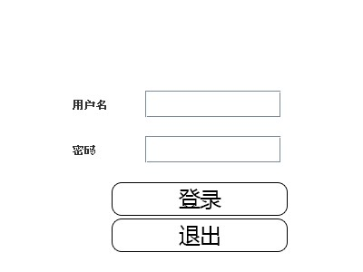

Enter the user name, password, and click [OK] button to the system registry.

Click [Exit] button to exit the system.

## 4.2Upload pictures

Enter the main page: click on the [Upload pictures] button to enter the interface to upload pictures.

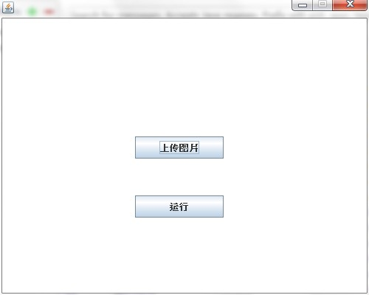

### 4.2.1View thumbnails

Upload pictures into the interface, you can view the pictures that have been uploaded, click on the list of records, and itwill show the thumbnailson the right.

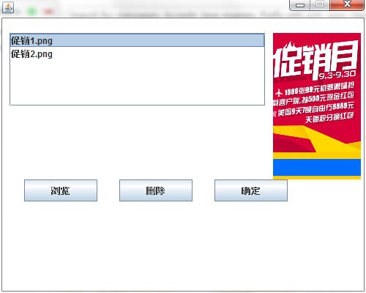

### 4.2.2Add a picture

Click Browse to bring up the file selection window, only select bmp, jpg, jpeg, gif, png image files. Select an image to upload files, double-click or click Open button, upload pictures. Click the [Cancel] button to close the file selection window.

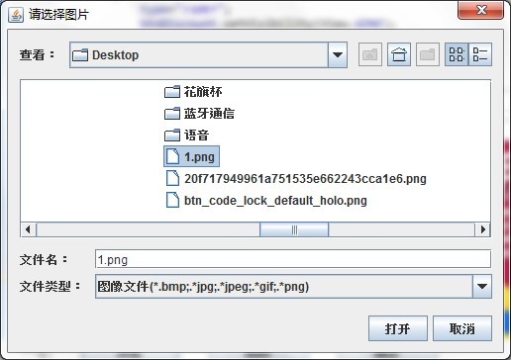

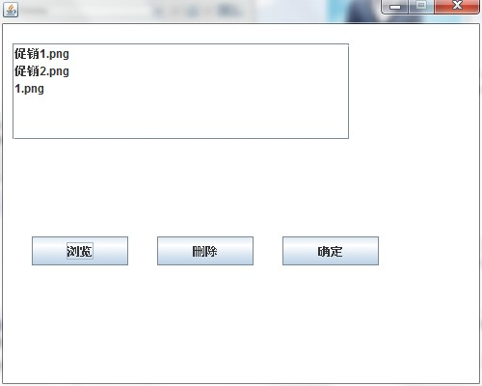

### 4.2.3Delete the picture

Select a record in the list, click [Delete] button, the picture is deleted from the database.

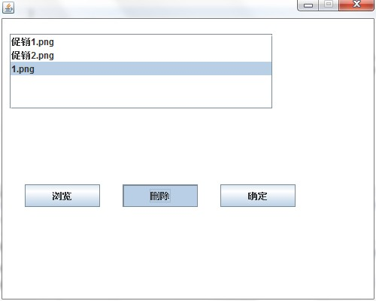

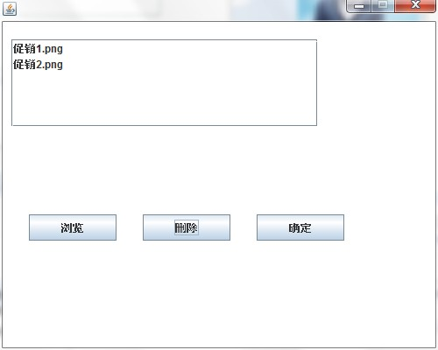

### 4.2.4complete the upload

Click the OK button or the close button in the upper right corner to close the upload picture screen.

## 4.3 run the server

In the main interface, click [Run] button to open the server program.

